Requirements Specifications

# The domain

As social medias has become a huge part of the human society, the value of information they carry is increasing day by day. Developing a method of efficiently finding information from a certain user group can be helpful in a lot of ways such as personal recommendations, society studies, etc.

In this project, our goal is to develop a dataset query that can show the most trending topic over a certain time period from a certain user group. The stakeholders of this project include researchers and bachelors who are eager to find out the interests of a certain group of people.

# Functional requirements

TwitterSearch is made up of three ADTs: ReadData, twitterADT and search. The program firstly read the information from the dataset, which is categorized as date, time, hashtag words, language, region, and like numbers. The user will be asked to choose the filtering conditions, and then the program will filter the stored data with those conditions, and count the numbers of how many times every hashtag word appears, then return the most frequently used one.

The ReadData class is used to read the dataset and load the information into a list a twitterADTs by using the function LoadUsers.

The twitterADT class defines the type twitterADT. Each twitterADT object collects the date, time language, region, hashtag and like number of each tweet.

The core function is defined in the class search. The function filter takes date, time language, region, hashtag and like number requirements and returns all the tweets that agree with requirements given. The search functions takes the list of twitterADTs returned and find the popular hashtags involved.

The UML specification:

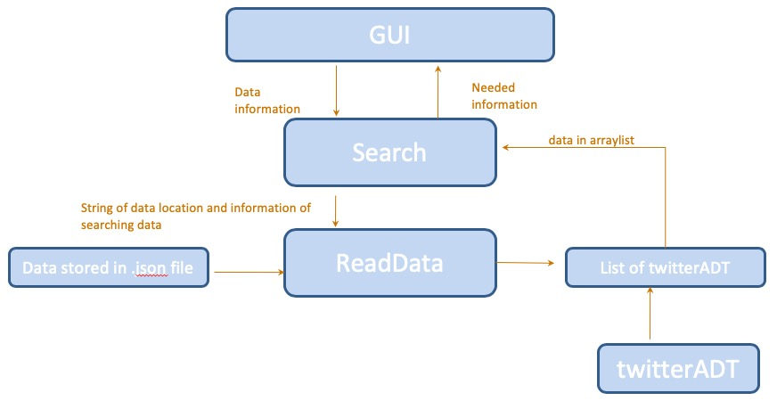

# Non-functional requirements

Security: Although the dataset to be used is open source, any information related to privacy should be protected.

Accuracy: This program should always return the correct result.

Performance: The algorithms used should be optimized so that latency can be minimized.

Usability: This program should be easy to use for users of any background knowledge.

# Requirements on the development and maintenance process.

Quality control procedures: This program should go through well designed tests to ensure each requirement is met.

Priorities of the required functions: First develop twitterADT ready to store information. Next, develop proper loader to read and collect information from dataset. Finally develop search algorithms that fulfills requiremets.

System maintenance procedures: This program should be constantly tested. Any bug or mistake emerged from testing and user report should be included in record and solved as soon as possible.